

Foundations of Programming

Assignment No.: 16
PROBLEM STATEMENT: To accept a list of N integers and partition the list into two sublists containing even and odd numbers.

OBJECTIVE:

- To understand how to work with arrays in C.
- To learn how to separate numbers based on conditions.
- To practice the use of loops and conditional statements.
- To display two different lists for even and odd numbers.

THEORY:
In C programming, arrays are used to store multiple values of the same data type. By using loops and conditional statements, it is possible to examine each element in the array and classify it based on certain conditions. In this program, the user enters N integers which are stored in an array. Each number is then checked using the modulus operator (%). If a number is divisible by 2, it is categorized as an even number; otherwise, it is an odd number. The program then displays two separate lists: one for even numbers and another for odd numbers.

ALGORITHM :
- START
- Declare variables:
integer n
array arr(n)
loop counter i
- Input value of n from user
- Read n integers and store into array arr(n)
- Initialise two empty lists:
even list
odd list
- Set i = 0
- Repeat while i < n:
a) Check if arr[i] % 2 == 0
b) If TRUE → add arr[i] to even list
c) Else → add arr[i] to odd list
d) Increment i by 1 (i = i + 1)
e) Go back to step 7
- Display all even numbers from even list
- Display all odd numbers from odd list
- STOP
PLATFORM: Linux

INPUT: Number of integers (N) and the list of integers.

OUTPUT: Displays two lists: Even numbers and Odd numbers.
SAMPLE INPUT:
Enter number of elements: 5
Enter integers: 10 7 4 9 12

SAMPLE OUTPUT:
Even numbers are: 10 4 12
Odd numbers are: 7 9

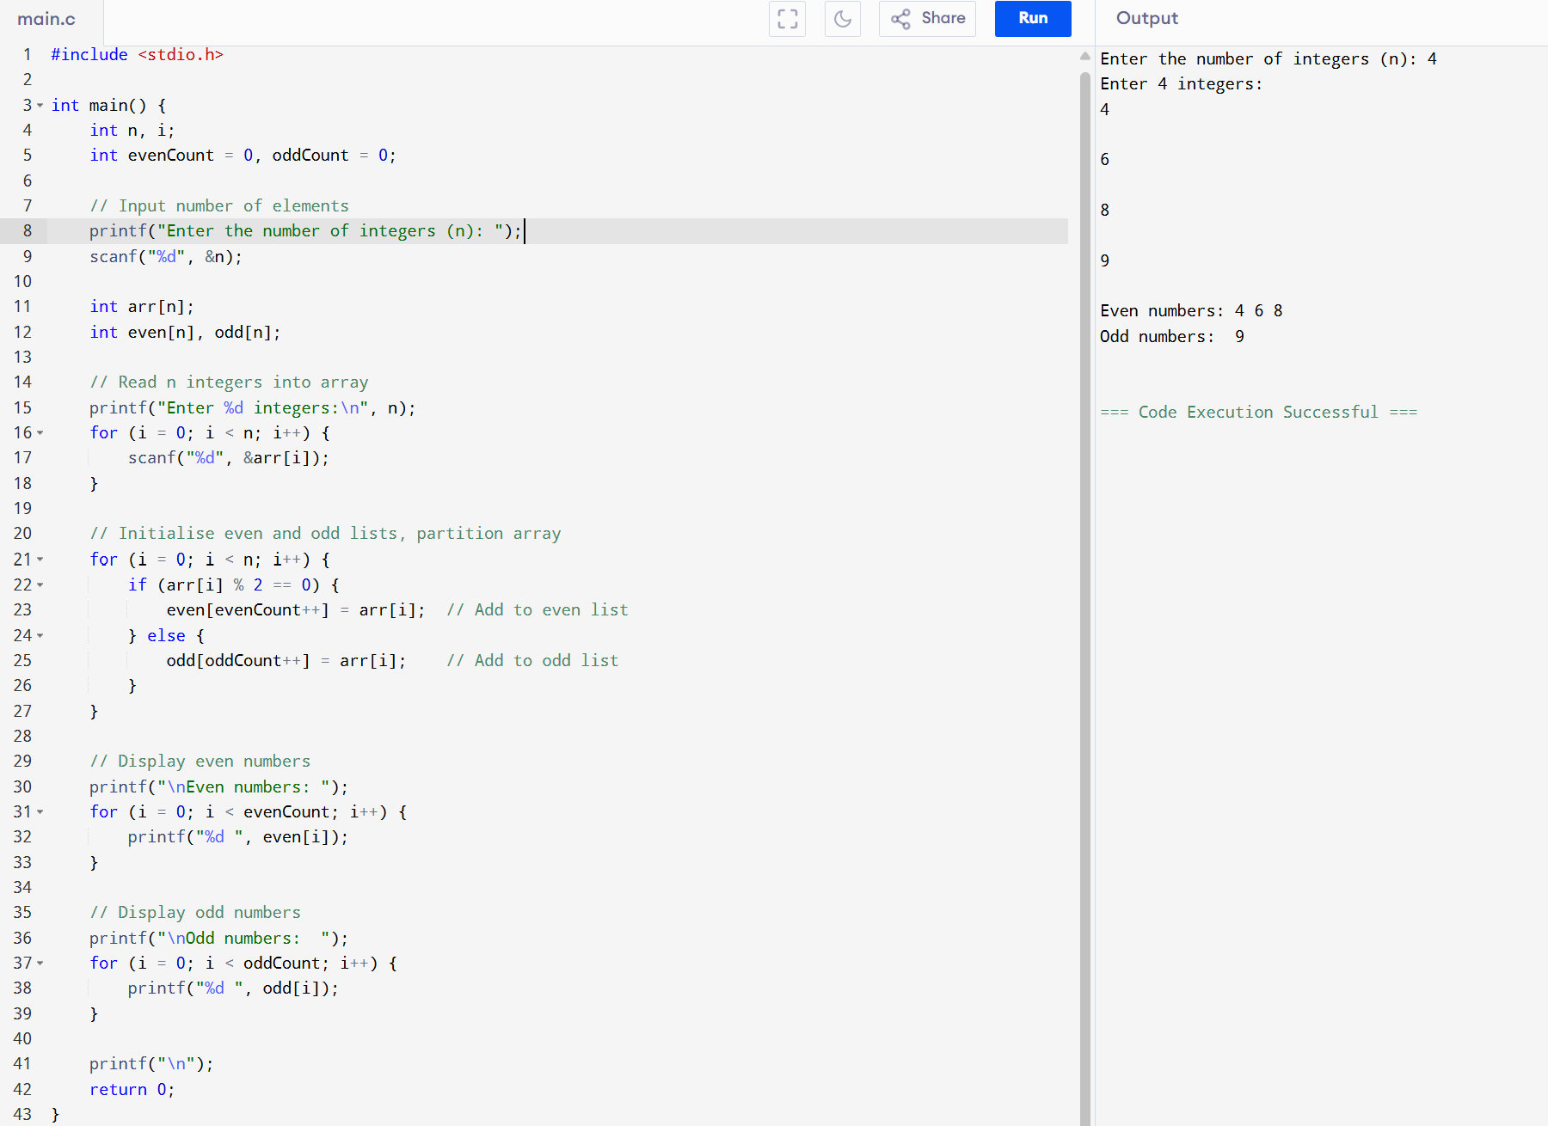

CONCLUSION: Thus, the C program successfully accepts a list of integers and partitions them into two separate lists of even and odd numbers.

FLOWCHART:
